
Company
Logotype

Cone Beam Computed Tomography- Report



Porur Dental X-rays & CBCT

Patient Name : Mrs. Sujitha | Date of Report : 11.07.2024
Age/ Gender : 28 years/ Female | Region of Interest : CBCT Full Skull
Referring doctor: Dr. Vanitha Mullan | Indication : Implant assessment
Clinical Notes: Nil
PATIENT INFORMATION

CBCT- Full skull provided
CBCT – IMAGE DETAILS

RADIOGRAPHIC INTERPRETATION

- Completely missing crown and root in relation to 13, 14, 23, 36, 37, 46, 47.
- Presence of bone loss extending beyond the apical third of all teeth that are present.
- Crown in relation to 11, 21

IMPLANT ASSESSMENT

 | 13 region | 14 region | 23 region
Sub-Crestal | 4.5 | 6.5 | 4.6
Mid- Crestal | 4.4 | 6.5 | 5.5
Distance between the alveolar ridge and Floor of the Nasal cavity (in mm) | 13.4 | 5.4 | 12.5

 | 36 region | 37 region | 46 region | 47 region
Sub-Crestal (in mm) | 11.7 | 8.3 | 6.2 | 9.9
Mid- Crestal (in mm) | 13.7 | 10.9 | 8.7 | 13.6
Distance between alveolar ridge and the inferior alveolar nerve canal (in mm) | 9.1 | 11.5 | 15.3 | 13.4
Distance between the alveolar ridge and lower border of mandible (in mm) | 16.9 | 20.2 | 23 | 20.5

RADIOGRAPHIC IMPRESSION

- Partially edentulous maxillary and mandibular arch.

Kindly correlate with clinical findings


IMAGES FOR REFERENCE

RECONSTRUCTED PANORAMIC VIEW

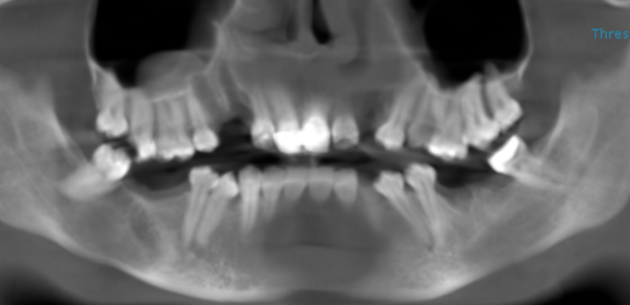

3-DIMENSIONAL VIEW

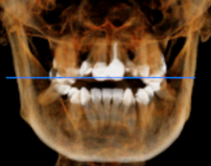

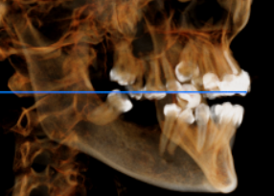
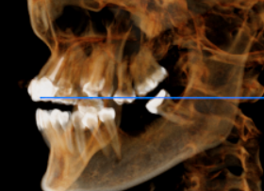

CROSS SECTIONAL VIEW

13 region | 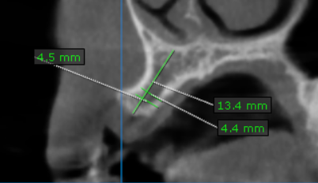
14 region | 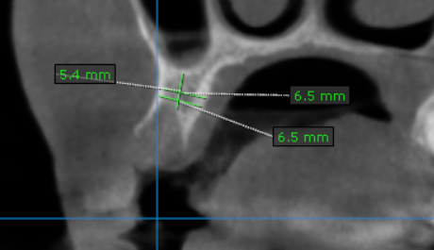
23 region | 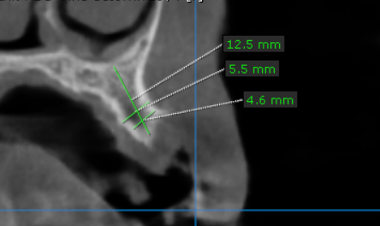
36 region | 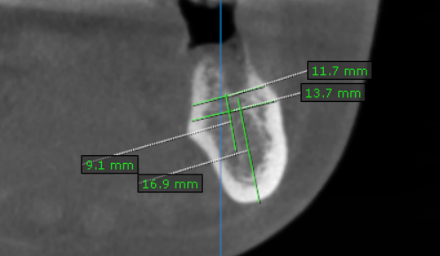
37 region | 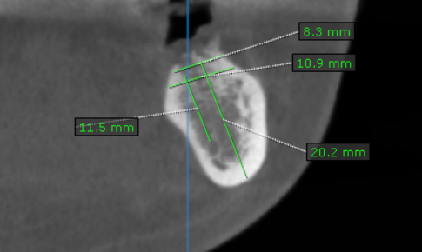
46 region | 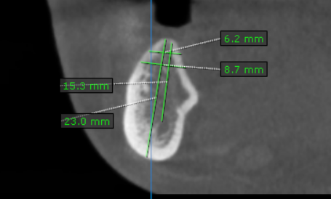
47 region | 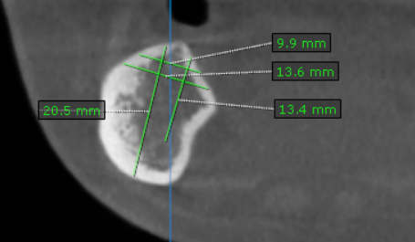

**** End of report ****

